## SP2 # 58 – Aquadag calibrations:

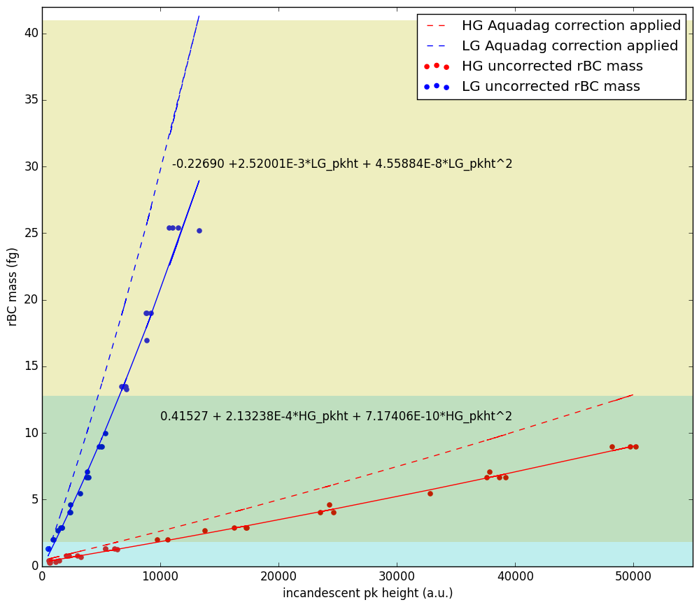

Figure 1 Calibration curves for the high gain (HG) and low gain (LG) broadband incandescent channels of SP2#58. Markers indicate the rBC mass calculated from measured Aquadag mobility diameter using the Gysel parameterization 1 as a function of the incandescent signal height. Solid lines are second-order polynomial fits to the measured data. Dashed lines are the same fits scaled to reflect the bias of the SP2 for Aquadag vs ambient soot.

**Calibration Notes:**

1. Calibrations were done on:
   1. Nov 6, 2012
   2. Aug 30, 2014
   3. April 11, 2015
   4. Dec 1, 2015
2. For the high gain channel all calibrations from 2012-2015 were combined and fit with a second order polynomial (red points and solid line above).
3. For the low gain channel all calibrations from 2012-2015 were combined and fit with a second order polynomial (blue points and solid line above). The only caveat to this is that for the 2012 calibration I excluded calibration data for Aquadag mobility diameters < 150 and > 450 since all of the other calibrations covered a narrower size range and did not include these smallest and largest particles.
4. Both fit lines were scaled by dividing by a factor of 0.7±0.05 to correct for the SP2 Aquadag bias (dashed lines above)
5. When using the high and low gain channels to arrive at the mass of a particle, the following procedure was used:
   1. Masses from 0.33-1.8fg were calculated using the high gain channel only (blue shaded region above)
   2. Masses from 12.8-41fg were calculated using the low gain channel only (yellow shaded region above)
   3. Masses from 1.8-12.8fg were calculated using the average result from the high and low gain channels (green shaded region above)
6. The uncertainty in the calculated mass concentrations (in the text files) reflects the combined uncertainty from the regression fit to the calibration data and the uncertainty in the Aquadag correction factor

bbhg_mass_uncorr = 0.29069 + 1.49267E-4*bbhg_incand_pk_amp + 5.02184E-10*bbhg_incand_pk_amp*bbhg_incand_pk_amp

bbhg_mass_uncertainty_uncorr = 0.06083 + 7.67522E-6*bbhg_incand_pk_amp + 1.60111E-10*bbhg_incand_pk_amp*bbhg_incand_pk_amp

bblg_mass_uncorr = -0.15884 + 0.00176*bblg_incand_pk_amp + 3.19118E-8*bblg_incand_pk_amp*bblg_incand_pk_amp

bblg_mass_uncertainty_uncorr = 0.47976 + 1.93451E-4*bblg_incand_pk_amp + 1.53274E-8*bblg_incand_pk_amp*bblg_incand_pk_amp